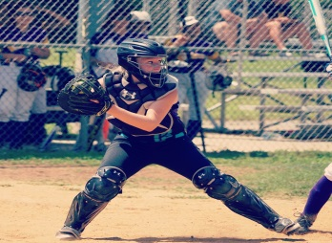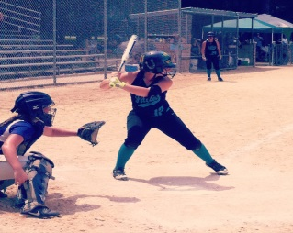
Makaylah Ann Mutz
Ulster Fillies 16U College Showcase
Rondout Valley High School – Class of 2017

Address: 310 Boice Mill Rd. City: Kerhonkson State: NY Zip: 12446
Home Phone: (845)-626-4068 Cell Phone: (585)-466-1750

Email: mutz4.me.com@gmail.com

Date of Birth: 07/01/99
Height: 5’6” Weight: 150lbs.
Bats: Right Throws: Right

Parents: Kevin & Dena Mutz
Parents Email\Phone: kmutz@hvc.rr.com
Father: (845)-464-3299
Mother: (845)-464-0017

Travel and HS - #12
Primary Position - Catcher
Secondary Positions - 3B, OF
Recruiting areas - Northest, Mid- Atlantic, Southeast
High school GPA – 3.25
SAT/ACT – Pending
Intended College studies – Physical therapy

Travel Coach:
Rick Spriggs
spriggsrick@yahoo.com
(845)399-8162

2016 Summer Travel Schedule

June 11 and 12 – Home Run College Showcase, Syracuse, NY

June 18 and 19 – Veteran’s Memorial, Matamoras, PA

June 30 through July 2 – TNT Summer Showcase, Quakertown, PA

July 8 – 10 – Tradition College Showcase, Meriden, CT

July 15 - 17 - Ulster Fillies Home Tournament, Saugerties, NY

July 26 through 30 – USSSA 16U Open Nationals, Salisbury, MD

2015/2016 Travel Season Statistics - (through 22 games)

AB – 51, Runs – 13, Hits – 22, RBI – 19, 2B – 4, 3B – 0, HR – 1, BB – 6, K – 7, SB – 4
Batting average - .431 Slugging % - .579 OBP % - .476

