Alexandria McKearin – CLASS OF 2018
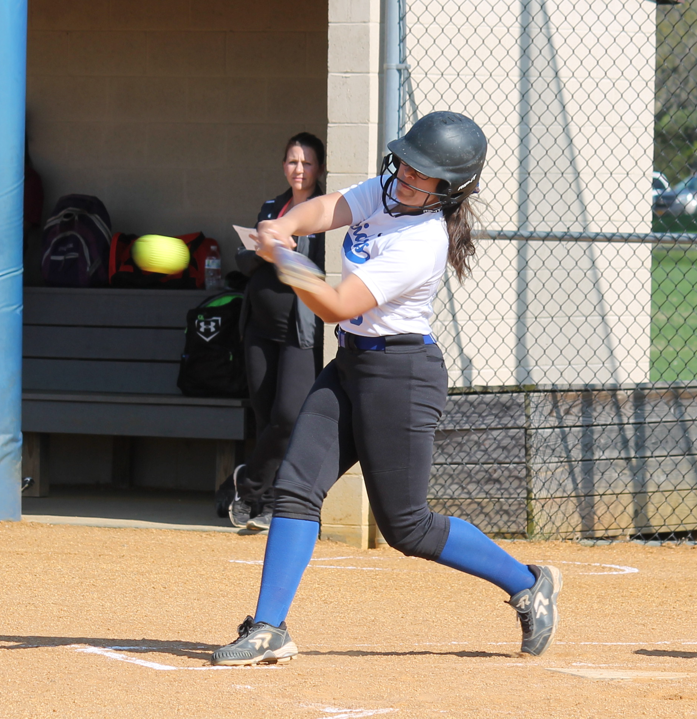 Ulster Fillies 16U College Showcase - #9 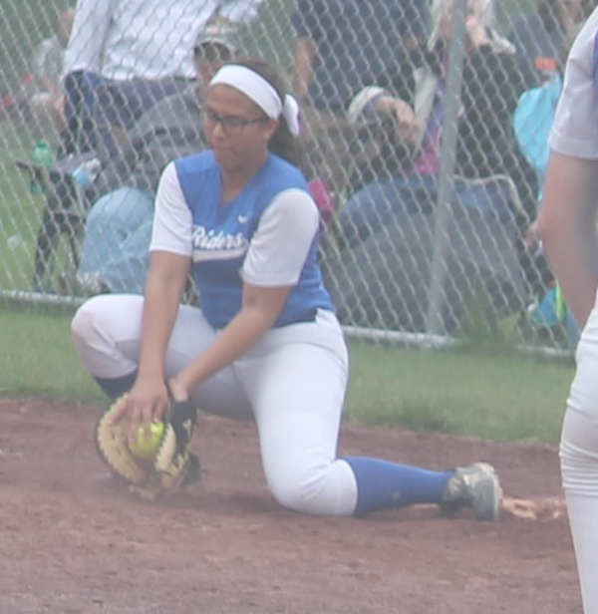
Throws: R Bats: L Weight: 5’5” Weight: 145
Position(s): 1B,3B, OF
High School: Ichabod Crane Central School District
GPA: 3.8 SAT: ACT:
NCAA Clearinghouse #:
Athletic/Academic Awards Student/Athlete data
DOB: June 9, 2000
NYS Attorney General 3C’s Award Street Address: 4701 Mazal Ct.
President’s Award for Academic Excellence Valatie, NY. 12184 All-County Band - 1, 2 Home phone: (518) 758-8450
HS Class President - 1, 2 Cell Phone: (518) 755-9055
Varsity Letter in 3 sports Parent(s): Francis and Michele McKearin
College studies interest: Biology/Medicine
Travel Coach: Rick Spriggs
Email: spriggsrick@yahoo.com
2015/2016 Fall/Spring Travel Softball Schedule Phone: (845)399-8162

Sept. 12 & 13 – Onondaga CCC Invitational Ulster Fillies/HS Statistics
In Syracuse, NY Year ‘16HS ‘15/’16 travel
Sept. 26 & 27 – September Showdown College
Showcase in Danbury, CT Games 27 27 October 10 & 11 – Homerun Softball College AB’s 77 44
Showcase in Syracuse, NY Hits 24 12
October 17 & 18 – New England’s Finest Runs 21 11
College Showcase in Plainville, MA RBI 24 8
October 24 – USSSA Dudley College 2B 5 4
Showcase in Danbury, CT 3B 1 0
January 15 – 17 – Adirondack Sports Dome HR 0 0
Complex in Queensbury, NY Average .312 .273
February 26 – 28 – Adirondack Sports Dome Slugging % .403 .364
Complex in Queensbury, NY On Base % .827 .429
Walks 14 12

2016 Summer Travel Softball Schedule
June 11 & 12 – Homerun Softball College Showcase in Syracuse, NY
June 18 & 19 – Tri-State Angels Tournament in Matamoras, PA
June 30 – July 3 – TNT Summer College Showcase in Quakertown, PA
July 9 & 10 – Tradition College Showcase in Meriden, CT
July 15 – 17 – Ulster Fillies Home Tournament in Saugerties, NY
July 25 through July 30 – USSSA “A” Nationals in Salisbury, MD

